SOLIDWORKS PROJECT

Name : Sarthak Aher
Roll No : 2024MEB1385

VERTICAL STIRLING ENGINE
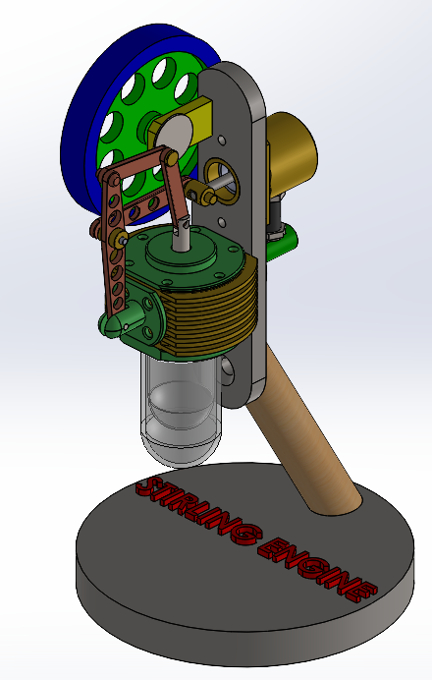
Objective:
The objective of designing and developing a Vertical Stirling Engine is to demonstrate the conversion of thermal energy into mechanical work using external heat sources through cyclic compression and expansion of air (or other working gases). This project aims to study the working principles of a Stirling engine, improve its thermal efficiency, and explore its potential applications in sustainable and low-emission power generation.

Working Principle:
The Vertical Stirling Engine works on the Stirling cycle, which involves the cyclic compression and expansion of a fixed amount of working gas (usually air, helium, or hydrogen) at different temperature levels.
Heat is supplied externally to one end of the engine (hot end) and removed from the other end (cold end).
As the gas alternately heats up and cools down, its pressure changes, causing the piston to move up and down, producing mechanical work.
The cycle mainly consists of four processes:
- Isothermal Expansion: The gas expands at the hot end when heated, pushing the piston upward.
- Constant Volume (Isochoric) Heat Transfer: The gas passes through the regenerator, transferring heat to it.
- Isothermal Compression: The gas is cooled at the cold end, reducing pressure and pulling the piston down.
- Constant Volume Heat Absorption: The gas again passes through the regenerator, regaining stored heat for the next cycle.

Project Description:
The Vertical Stirling Engine project is designed to demonstrate the conversion of thermal energy into mechanical work using an external heat source. The engine operates on the Stirling cycle, which involves the cyclic heating and cooling of air inside a closed cylinder.
In this project, the engine consists of a displacer piston, power piston, heater, cooler, and flywheel arranged in a vertical position. When heat is supplied to the lower (hot) end, the air expands and pushes the piston upward. The air then moves to the upper (cold) end, cools down, and contracts, pulling the piston downward. This repeated motion of the piston turns the flywheel, producing smooth rotational motion.
The project helps understand how external combustion engines can generate power efficiently, operate quietly, and use various heat sources such as solar, gas flame, or waste heat.

Applications of Vertical Stirling Engine:
- Power Generation – Used in small-scale power plants to generate electricity from solar, geothermal, or waste heat sources.
- Solar Energy Systems – Works efficiently with solar concentrators to convert sunlight into mechanical or electrical energy.
- Cooling and Refrigeration – Can be operated in reverse as a Stirling cooler for air-conditioning and cryogenic cooling.
- Educational Demonstrations – Commonly used in schools and colleges to demonstrate thermodynamic principles and heat engine concepts.
- Waste Heat Recovery – Utilized to convert industrial or engine waste heat into useful mechanical power.

